Outline:

Kinestheticaly rhythmic platformer
Core pillars:
Rhythmic feel
Positionaly tactical
Target platform:
Web
Android
You are a bug descending down a tree. The tree is infinite, but there are stages. Get’s more difficult the further you go. More instruments kick in as well.
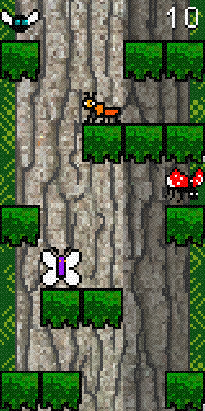

Player moves left, right and jumps.
Contact with enemies kills player, jumping on enemies kills them

Soundtrack:
The soundtrack will be made as a Tracker file of some format tbd. The speed and enabled instruments change the more the player progresses.
Have to:
Decide on format
Research formats
Get good instruments/samples
Research what instruments/samples other people use
Make tracker song
Sections have to sound good coming in/out of the song
Match BPM of the level generation, and accentuate it with a bassy tone
Has more intricate/syncapated parts the more enemies are on screen
Has to loop perfectly

Art:
Using stuff i already made

Code:

LevelMatrix:
The level consists of this floor matrix, colored green is every floor block that is randomly generated as part of a row that is pushed from the bottom, causing all rows to shift one row up.
i = 0
i = 1
i = 2
i = 3
i = 4
i - rowIndex
Level is stored as a list of Rows, which are in turn lists of floorBlocks that are static in the scene

Level is an Object held by LevelMaster
Level :Object
List<List<floorBlock>> levelRows

func setRowState(rowIndex, Row):
Replaces existing row data at rowIndex with new Row
Changes visibility of each floorBlock

func getRowState(rowIndex):
Returns the row data at index
func pushNewRowFromBottom(Row = null):
var row = Row
If row == null:
row = generateRandomRow()

For i in levelRows.size():
if i == 4:
setRowState(i, row)
else:
setRowState(i, getRowState(i+1))

Tracker Integration:
Need to research this https://wiki.openmpt.org/Manual:_Module_formats

Level Master:
Node inside of the Level scene,
holds references to all the floorBlock StaticBodies,
Makes sure level generation and Dj are synced.
operates the LevelMatrix, handles enemy spawners,
instructs Dj on
What instruments to toggle on/off
the song tempo,
the track to play

LevelMaster extends Node

var Score :int
var Level :LevelMatrix
Export var floorBlocks :List<floorBlock>
Onready var dj :Dj

func initLevel()
func spawnPlayer()
func pushNewRow()
func setTrackComplexity(numEnemies: int)
func decreaseTrackComplexety()
func changeTrackAfterThisSection(Track)
func increaseScore()
func onPlayerDead()

Dj:
Tracker integration needed

Input:
Web -
arrow keys left right
space/up key - jump

Enemies:
Spawned from 3 different spawners from top of the screen
Spawners have transforms, Level Master triggers them, and sets their tim

Deployment:

Android

Web

Estimates:

Task | Time Estimated | Deadline | Time to Complete | Date Complete | ECR
GDD draft finished | 4h | 4.2 20:00 | 3h | 4.2 19:50 | 1.3

